**Implications**

An implication that I had to consider when creating my program was intellectual property. When somebody creates something – whether it be a piece of writing, code, an image, etc. – putting it on the internet does not mean that it is free to use. Unless it has been explicitly otherwise stated, you should always credit the creator of the original work if you include it in your own work. This can also help you to avoid legal issues if/when you publish work that contains other people’s intellectual properties, if they decide to take action against your use of their work.

In the earlier versions of my program, I used a pancake recipe that was not my own to use in place of the user input. I found this recipe here: <https://www.chelsea.co.nz/browse-recipes/sunday-pancake-recipe/>. To address this implication, I had to credit the recipe to protect myself against legal action if I ever published these versions of the code, and to respect that this is not my intellectual property. To do so, I simply included a print statement (which is shown on the user end of the program so that the credit was not hidden inside of the code) with the name of the company that created the recipe and a link that the user could copy and paste into their web browser to see the original recipe.

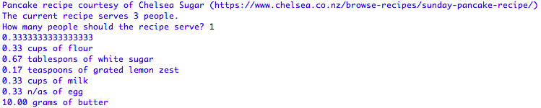

A screenshot from the output of version two of the program, which used the recipe. As you can see at the top of the screenshot, I have credited the recipe.

Another implication that I considered in the production of my program was usability. This means that the program runs efficiently for users, and it is easy and enjoyable to use. The aim of making a program to convert recipes is to make baking easier, so it is no use if the program is difficult to use. Good usability means that the user feels in control when they are using the program and are able to navigate it easily. If they make a mistake while inputting the data, the program should be able to recover from this and remedy the error. The program should be consistent with the language it uses and the way it runs so as to not confuse the user.

There are multiple ways that I addressed this implication. One example is my instruction message at the start of the program. While the program’s input prompts are instructive and are clear with what they want from the user each step of the way, when starting up the program it is best if the user understands what is going to happen and what the program needs from them. Therefore, I added a brief welcome message with basic instructions to minimise the user’s confusion the first time they use the program. It is not overly detailed, either, because I did not want to overwhelm new users with too much information.

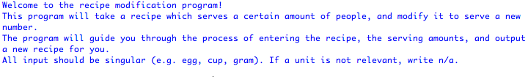

A screenshot of the welcome message used in my program.

Another example of how I addressed this implication is my error handling system. There are multiple times in the program where I want the user to enter a specific type of data (e.g. a float or an int). Usually, if they enter something different (e.g. a string) into these types of input fields, the program would crash, and the user would have to restart it. To prevent this, in the final stages of developing my program I added some functions that would allow the user to re-enter the input if they made a mistake instead of the program crashing. An error message prints out instructing them what sort of input the program is looking for, and the input prompt is repeated until they enter something that the program can work with.

­ 

A screenshot of the error message and the repeated question.

**Discussion of the Development of the Outcome**

The information from planning, testing, and trialling the components of my program assisted me to create a high-quality outcome.

One part of planning that helped increase the quality of my outcome was decomposing the program into manageable parts that I could code and combine into different versions. This meant that I didn’t have to focus on the entire program at once, and I could get each section to work before I reached a finished product. For my project management I used a Trello board, and represented each component of the program with a “card”. Using this to help focus my attention on certain aspects and complete each to a high quality increased the overall quality of my final outcome.

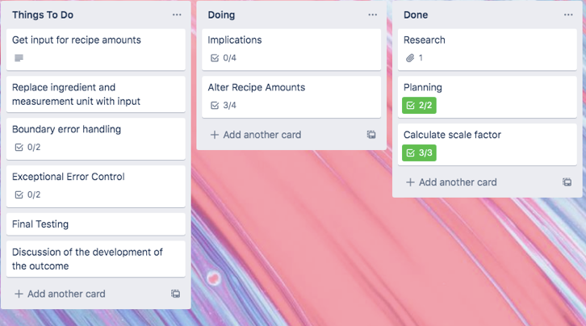

A screenshot of my board during the earlier stages of developing my program. As you can see in the board’s activity history, I altered the cards and moved them around as I worked to keep track of my progress and help me focus on certain components of the program.

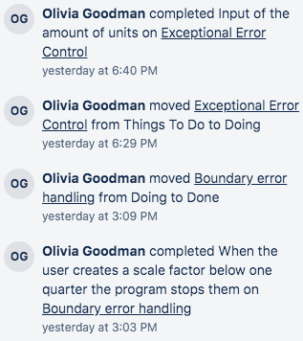 A screenshot showing part of the activity history. I would complete tasks and move cards as I finished what needed to be done.

Trialling different ways of running my program based on testing evidence also helped increase the quality of the finished outcome. As discussed in the testing document, I originally tried out a menu-based input system for the user to input the recipe. I thought that this might be a good idea, as the user will feel in control of the input process. However, through testing, I came across multiple problems (these have been listed in the testing document, so I will not go over them again here). Using this information, I then tested out a different way of getting the input from the user. They had the option to quit each time they started a new ingredient, but once they inputted an ingredient they had to provide a relevant unit and amount for that ingredient. This helped avoid the problems that I found in the previous method. Testing the original program and using the findings I got from that to improve the functionality of my program helped increase the overall quality of the final outcome.

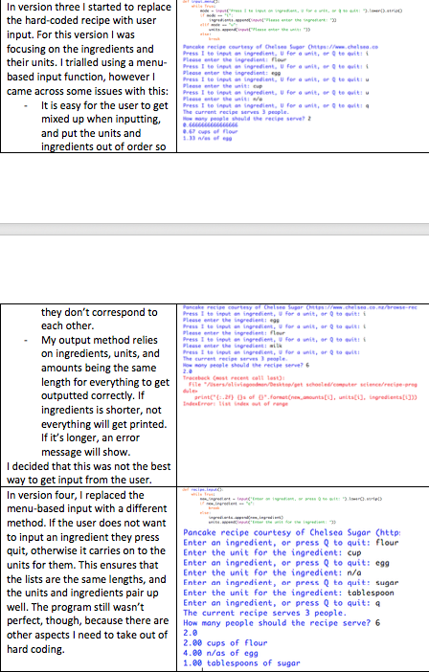 A screenshot of the testing document that shows the differences between the two versions and the reasons why I changed it.

One thing that I would do in the future if I had more time to help the quality of my outcome even further is to do testing with somebody other than myself. This could be a friend or family member, or if possible a baker because they are who the program is aimed at. Getting other opinions would be extremely valuable, because as the person who created the program I am very used to how it works and may not pick up on certain errors or parts of it which are hard to use. However, I did not have time to do this before the due date of the assignment.